Electrical Automation Technology, Control Systems Technology & Electrical Design Systems Technology
Performance Test #2, Switches and Receptacles

Name _________________________ Instructor Verification __________ Grade __________

Materials:
Materials Provided by You | Materials Provided by the Department
1. Necessary Tools | 1. Single Pole Switch
2. NM-B or MC Cable | 2. Duplex Receptacle
3. Wire Kit | 3.Lamp Holder

Objective:
Given necessary materials, the student will construct an electrical circuit according to the specifications listed, as evidenced by scoring a minimum of 75% on this test.

Time Limit:
You are allowed 50 minutes to complete the circuit. Five points for every five minutes over the allotted time will be deducted from the score. The maximum overtime allowed is fifteen minutes.

Description of the Circuit:
Construct a circuit in which power is fed to a duplex receptacle box. There is a switch that controls a light. The duplex receptacle is “hot” at all time. All devices are installed in metal boxes and the lamp holder is installed in a metal box. This circuit is to be completed within 50 minute time limit.

Part 1 (+50 points):
Using a straight edge, draw how this circuit will be wired. Five points will be deducted for each error.
Start Time: __________ Finish Time: __________

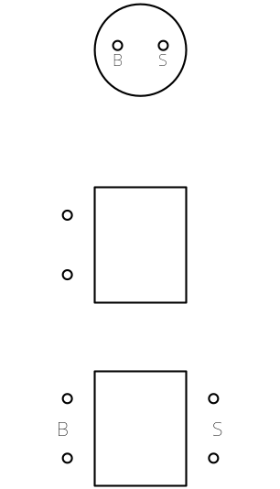

Performance Test # 2

Part #2 (+50points):
Construct the circuit.

__________ Circuit wired correctly. +5 points

__________ 6” of free conductor from the edge of the box. +5 points

__________ Wire nut connections secure. +5 points

________ Conductors on devices correctly. +5 points

_________ 1/4" cable sheath inside box. +10 points (if NM-B is used)

_________ All anti-short bushings in place. +10 points (if MC is used)

_________ Circuit works as described. +20 points (Troubleshooting yourself +10)

